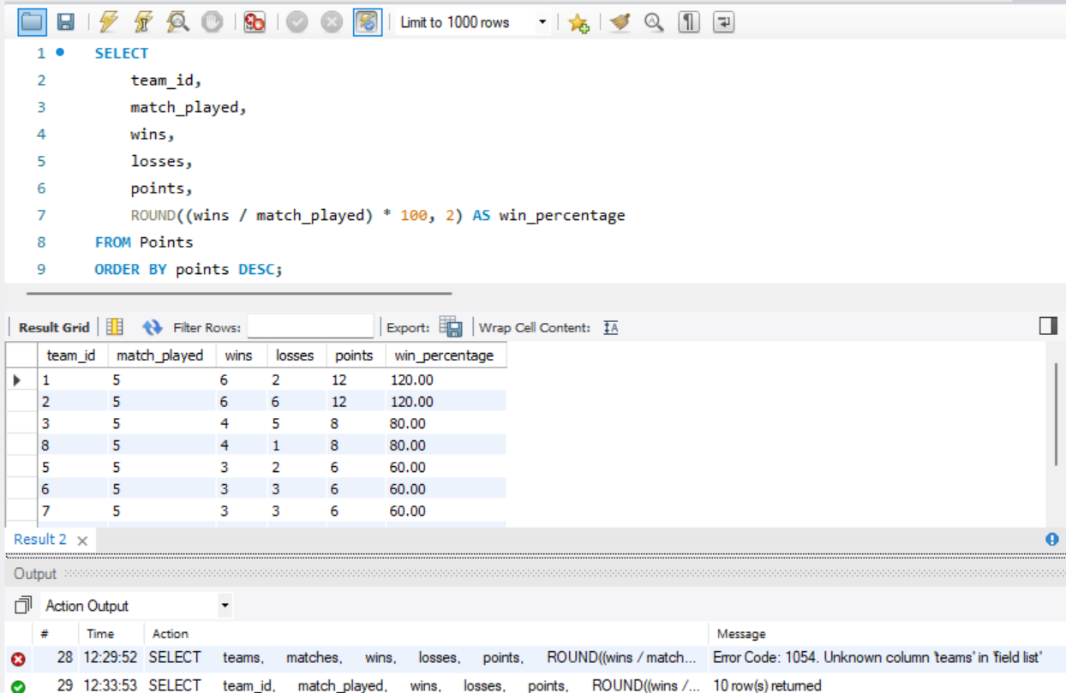

**#Team-wise Performance Summary**

* **Total matches played, wins, losses, points, and net run rate (NRR).**
* **Sorted by points (highest to lowest).**

SELECT

team_id,

match_played,

wins,

losses,

points,

ROUND((wins / match_played) * 100, 2) AS win_percentage

FROM Points

ORDER BY points DESC;